**E To-Let Management System**



Report on

**Software Requirements Specification**

**Submitted To** Dr. Md Shahriar Rahman  
Associate Professor   
Department of Computer Science & Engineering

University of Liberal Arts Bangladesh

**Submitted By**

Sakif Ahmed Abir (151014085)

1. Introduction………………………………………………………………………………………………………………………………………………………………………….03

Table of Content

1.1 Purpose…………………………………………………………………………………………………………………………………………………………………..03

1.2 Scope……………………………………………………………………………………………………………………………………………………………………….03

1.3 Definitions, Acronyms, and Abbreviations………………………………………………………………………………………………………………..04

1.4 References……………………………………………………………………………………………………………………………………….……………………….04

1.5 Overview……………………………………………………………………………………………………………………………………………………………………05

2. Overall Description………………………………………………………………………………………………………………………………………………….…………….05

3. Specific Requirements…………………………………………………………………………………………………………………………………….……………………….05

3.1 Functionality………………………………………………………………………………………………………………………………………………………………06

3.1.1 Sell Configured to Book Products………………………………………………………………………………………………….…………………06

3.1.2 Provide comprehensive Sevice details………………………………………………………………………………………………………..…..06

3.1.3 Detailed Service Categorizations……………………………………………………………………………………………………………………..06

3.1.4 Maintain customer profile……………………………………………………………………………………………………………….………………06

3.1.5 Provide personalized profile…………………………………………………………………………………………………………………….……..07

3.1.6 Provide Customer Support………………………………………………………………………………………………………………………………07

3.1.7 Email confirmation……………………………………………………………………………………………………………………………..…………..07

3.1.8 Detailed invoice for customer……………………………………………………………………………………………………………….…………07

3.1.9 Provide Booking facility……………………………………………………………………………………………………………………………………07

3.1.10 Allow online change or cancellation of Booking…………………………………………………………………………………….…………07

3.1.11 Provide detailed location map……………………………………………………………………………………………….………………………..08

3.1.12 Online Booking………………………………………………………………………………………………………………………………..………………08

3.2Usability ………………………………………………………………………………………………………………………………………………………………………..…08

3.2.1 Graphical User Interface……………..…………………………………………………………………………………………………………………..08

3.2.2 Accessibility…………..…………………………………………………………………………………………………………………………………………08

3.3 Maintenances………………………………………………………………………………………………………………………………………………..………..08

3.4 Performance…………………………………………………………………………………………..……………………………………………………….…………….09  
 3.4.1 LeTency…………………………………………………………………………..………………………………………………………………………………..09  
 3.4.2 Response Time ………………………………………………………………………………………………………………………………………………….09

3.5 Security ……………………………………………………………………………………………………………………………………………………………………..09

3.5.1 Data Transfer………………..…………………………………………………………………………………………………………………………………10

3.5.2 Data Storage………………………………………………………………..………………………………………………………………………………….10

3.6 Assumption ……………………………………………………………………………………………………………………………………………………………….10

3.7 Supportability………………………………………………………………………………………………………………………………………….…………………………10   
 3.7.1 Configuration Management Tool……………………………………………………………………………..……………………………………………….10  
 3.8 Design Constraints……………………………………………………………………………………………………………………………..………………………………..10  
 3.8.1 Standard Development Tools…………………………………………………………………………………………….…………………………………………10  
 3.8.2 Web Based Product……………………………………………………………………………………………………….…………………………………………….11

3.9 On-line User Documentation and Help System Requirements ……………………………………………………………………………………11

3.10 BookingComponents …………………………………………………………………………………………………………………………………………………11

3.11 Interfaces …………………………………………………………………………………………………………………………………………………………….11

3.11.1 User Interfaces…………………………………………………………………………………………………………………………………………………12

3.11.2 Hardware Interfaces…………………………………………………………………………………………………………………………………………12

3.11.3 Software Interfaces………………………………………………………………………………………………………………………………………….12

3.11.4 Communications Interfaces…………………………………………………………………………………………………………………………….12

3.12 Licensing Requirements ………………………………………………………………………………………………………………………………………..12

3.13 Legal, Copyright, and Other Notices ………………………………………………………………………………………………………………………12

4. Supporting Information …………………………………………………………………………………………………………………………………………13  
 4.1 ER DIagram……………………………………………………………………………………………………………………………………………..………………..13  
 4.2 DFD………………………………………………………………………………………………………………………………………………..…………………………..14  
 4.3 Flow Chart Diagram…………………………………………………………………………………………………………………………………………………….15

4.4 UML Diagram………………………………………………………………………………………………………………………………………………18

1. Introduction

The introduction of the software Requirements Specification (SRS) provides an overview of the entire SRS with purpose, scope, definition, acronyms, abbreviations, references and overview of the SRS. The aim of this documents is to gather and analyze and give an in-depth insight of the complete E To-Let Management System by defining the problem statement in detail.

Nerveless, it also concentrates on the capabilities required by stakeholders and their needs while defining high level product features. The detailed requirements of the E To-Let Management System are provided in this document.

1.1 Purpose

The purpose of the document is to collect and analyze all assorted ideas that have come up to define the system, its requirements with respect to consumers. Also, we shall predict and sort out how we hope this product will be used in order to gain a better understanding of the project, outline concepts that may be developed later, and document ideas that are being considered, but may be discarded as the product develops.

In short, the purpose of this SRS document is to provide a detailed overview of our software product, its parameters and goals. This document describes the project's target audience and its user interface, hardware and software requirements. It defines how our client, team and audience see the product and its functionality. Nonetheless, it helps any designer and developer to assist in software delivery lifecycle (SDLC) processes.

1.2 Scope

Primarily, the scope pertains to the E To-Let Management System features for making those people who are not able to find out their suitable apartment for them. It focuses on the online based software which allow for online booking system for their rental apartment. People are very busy in their daily life now. So it’s very difficult for anybody to manage time for searching. This   
software will assist people to find out their suitable apartment through the Internet from anywhere.  
 03

There is no popular website for house rent in Bangladesh. Our website will be the best possible option for people who want to live in rental apartment in Dhaka city. This website is very much user friendly.

This SRS is also aimed at specifying requirements of software to be developed but it can also be applied to assist in the selection of in-house and commercial software products. The standard can be used to create software requirements specifications directly or can be used as a model for defining a organization or project specific standard. It does not identify any specific method, nomenclature or tool for preparing an SRS.

1.3 Definition, Acronyms & Abbreviation

|  |  |
| --- | --- |
| Configuration | It means a product which is available/ selected form a catalogue can be customized |
| PHP | Personal Home Page |
| HTML | Hypertext Markup Language |
| HTTP | Hypertext Transfer Protocol |
| CSS | Cascading Style Sheets |
| TCP | Transmission Control Protocol |
| IP | Internet Protocol |

1.4 References

Still we do not use any reference in our project. When, we will create our project, we will attached references.

04

1.5 Overview

The remaining sections of this document provide a general description, including characteristics of the users of this project, the product's hardware, and the functional and data requirements of the product.  General description of the project is discussed in section 2 of this document.  Section 3 gives the functional requirements, data requirements and constraints and assumptions made while designing the E To-Let Management System.  It also gives the user viewpoint of product.  Section 3 also gives the specific requirements of the product.  Section 3 also discusses the external interface requirements and gives detailed description of functional requirements. Section 4 is for supporting information.

2. Overall Description

This document contains the problem statement that the current system is facing which is hampering the growth opportunities of the company. It further contains a list of the stakeholders and users of the proposed solution. It also illustrates the needs and wants of the stakeholders that were identified in the brainstorming exercise as part of the requirements workshop. It further lists and briefly describes the major features and a brief description of each of the proposed system.

The following SRS contains the detail product perspective from different stakeholders. It provides the detail product functions of E To-Let Management System with user characteristics permitted constraints, assumptions and dependencies and requirements subsets.

3. Specific Requirements

The Specific requirements are given below step by step

05

3.1 Functionality

This subsection contains the requirements for the E To-Let Management System. These requirements are organized by the features discussed in the vision document. Features from vision documents are then refined into use case diagrams and to sequence diagram to best capture the functional requirements of the system. All these functional requirements can be traced using tractability matrix.

### 3.1.1 Sell Configured to Booking Products

#### The system will display all the products that can be configured.

#### The system will allow user to select the product to configure.

#### The system will display all the available components of the product to configure.

#### The system will enable user to add one or more component to the configuration.

### 3.1.2 Provide Comprehensive Service Details

1. The system will display detailed information of the selected products.
2. The system will provide browsing options to see product details.

3.1.3 Detailed Service Categorizations

1. The System will display detailed Service categorization to the user.

3.1.4 Maintain Customer Profile

1. The System will allow user to create profile that can s/he access the system.

1. The System will allow user to update the profile information.

06

3.1.5 Provide personalized profile

1. The system will display both the active and completed order history in the customer profile.
2. The system will allow user to select the order from the order history.
3. The system will display the detailed information about the selected order.

3.1.6 Provided Customer Support

1. The system will display the customer support contact numbers on the screen.
2. The system will allow user to enter the contact number for support personnel to call.
3. The system will display the online help upon request.

3.1.7 Email Confirmation

1. The system will maintain customer email information as a required part of customer profile.

3.1.8 Detailed invoice for customer

1. The system will display detailed invoice for current order once it is confirmed.
2. The system will optionally allow user to print the invoice.

3.1.9 Provide Booking facility

1. The system will provide booking facility during online confirmation.
2. The system will allow user to add/remove service in the booking system.

3.1.10 Allow online change or cancellation of Booking

1. The system will allow user to select the booking to be changed.
2. The system will allow user to cancel the booking.

07

3.1.11 Provide detailed Location map

1. The system will allow user to view detailed location map with area.

3.1.12 Online Booking

..

1. The system shall allow user to confirm the booking.

3.2 Usability

These usability are given below:

3.2.1 Graphical User Interface

1. The system will provide a uniform look and feel between all the web pages.
2. The system will provide a digital image for each product in the product catalog.
3. The system will provide use of icons , toolbars.

3.2.2 Accessibility

1. The system will provide multi access.
2. The system will provide only English language support.
3. The system has that authority to ban any one access in our website without any previous notice.

3.3 Maintenances

This subsection specifies the following requirements associated with the ease with which the system can be maintained:

08

1. The system will permit the upgrade of software without down time.

3.4 Performances

This subsection specifies the following requirements associated with the speed with which the system will function.

3.4.1 Latency

This subsection specifies the following requirements concerning the maximum time that is permitted for the system to execute specific tasks (i.e., system operations) or use case paths end to end:

* A customer will be able to sign in the system from the internet for within 10 seconds.
* A customer will be able to sign in the system and make an online booking from the internet for within 1 minute (assuming that the customer knows what to book)

3.4.2 Response Time

This subsection specifies the following requirements concerning the maximum time that is permitted for the system to respond to requests:

* No system responses will occur exceeding 1 minute.

3.5 Security

Security is very important for any software. Without security, the software will not secure.

3.5.1 Data Transfer

1. The system will automatically log out all customers after a period of inactivity.
2. The system will not leave any cookies on the customers computer containing the users password.
3. The system will not leave any cookies on the customers computer containing any of the user’s confidential information.

09

3.5.2 Data Storage

1. The systems back-end servers will never display a customer’s password. The customer’s password may be reset but never shown.
2. The systems back-end servers will only be accessible to authenticated administrators.
3. The systems back-end databases will be encrypted.

3.6 Assumptions

Based on few reasons this website developed. Few of them are describing here:

1. Accommodation Problem for people.
2. Busy life schedule.
3. Information limitation.
4. Lack of knowledge of people about an area.

3.7 Supportability:

3.7.1 Configuration Management Tool

The source code developed for this system will be maintained in configuration management tool.

3.8 Design Constraints

3.8.1 Standard Development Tools

The system will be built using a standard web page development tool. Those development tools are given below:

1. PHP.
2. HTML.
3. CSS.
4. Database-MYSQL.  
    10

3.8.2 Web Based Service

1. There are no memory requirements
2. The computers must be equipped with web browsers such as Internet explorer Chrome.
3. The product must be stored in such a way that allows the client easy access to it.
4. Response time for loading the product should take no longer than 1 minutes.
5. A general knowledge of basic computer skills is required to use the product.

3.9 On-line user Documentation & Help System Requirements

As the product is E-To-Let Management System, On-line help system becomes a critical component of the system which will provide –

1. It will provide specific guidelines to a user for using the E-To-Let Management system and within the system.
2. To implement online user help, link and search fields shall be provided.

3.10 Booking Component

Not Applicable

3.11 Interfaces

Interface means a point where two systems, subjects, organizations, etc. meet and inter.

There are many types of interfaces as such supported by the E To-Let Management software system name :

User Interface,

Software Interface &

Hardware Interface.

The protocol used shall be HTTP. The Port number used will be 80. There shall be logical address of the system in IPv4 format.

11

3.11.1 User Interfaces

The user interface for the software shall be compatible to any browser such as Internet Explorer Mozilla, Chrome or Netscape Navigator by which user can access to the system.

3.11.2 Software Interfaces

1. The E To-Let Management system will communicate with the Configurator to identify all the available components to configure the product.
2. The E To-Let Management system will communicate with Agent to provide support.
3. The E To-Let Management system will communicate with export regulation system to validate export regulations.

3.11.3 Hardware Interfaces

Since the application must run over the internet, all the hardware shall require to connect internet will be hardware interface for the system. As for e.g. Modem, WAN – LAN, Ethernet Cross-Cable.

3.11.4 Communication Interfaces

The E To-Let Management system shall use the HTTP protocol for communication over the internet and for the intranet communication will be through TCP/IP protocol suite.

Not Applicable.

3.12 Licensing Requirements

3.13 Legal, Copyright & Other Notices

E To-Let should display the disclaimers, copyright, word mark, trademark and product warranties of the E To-Let Management System.

12

4 Supporting Information

Supporting information are given below:

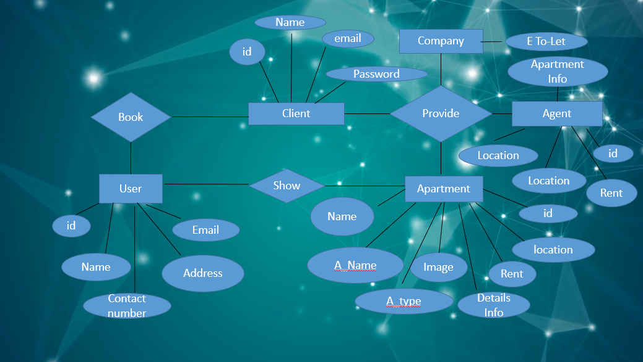

4.1 ER Diagram

13

4.2 Data Flow Diagram

DFD means data flow diagram. A data flow diagram is a graphical representation of the flow of data through an information system, modeling its process aspects. There are many types of DFD such as:

* Context Level DFD.
* 0 – Level DFD.
* 1 - Level DFD.
* 2 – Level DFD & so on

The 0 level DFD E To-Let management system are given below:

**Activity**

* WEBSITE.
* BOOK.
* SERVICE.
* SUPPLY CHAIN MANAGEMENT (S/M).
* PAYROLL.

**ENTITY**

* ADMIN.
* VISITOR.
* CUSTOMER.
* AGENT.

14

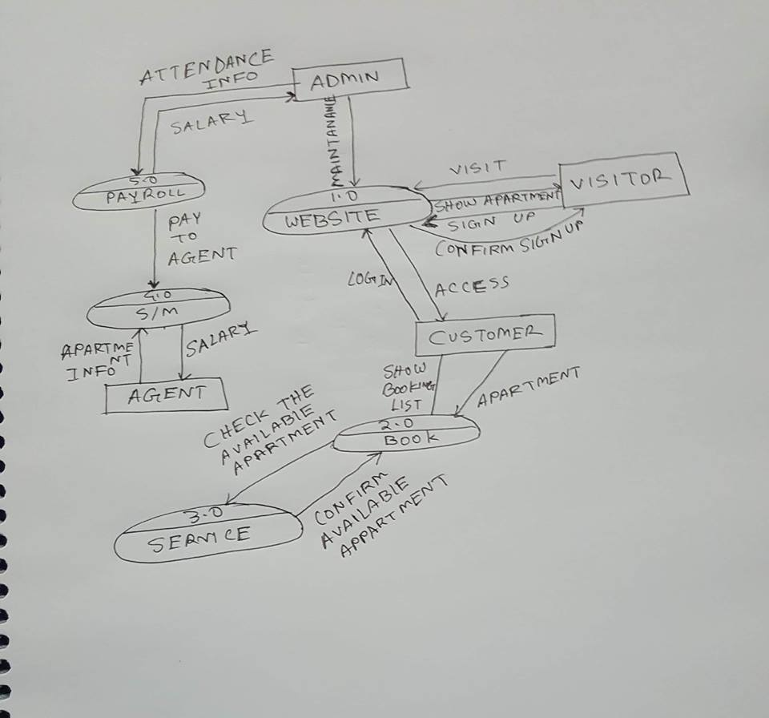

4.3 Flow Chart Diagram

A flowchart is a type of diagram that represents an algorithm, workflow or process, showing the steps as boxes of various kinds, and their order by connecting them with arrows.

The flow chart diagram of E To-Let management system is given below:

15

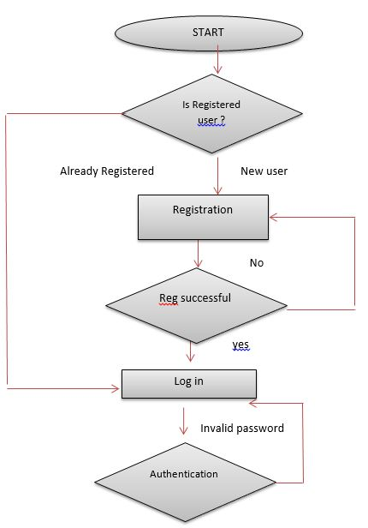  
16  
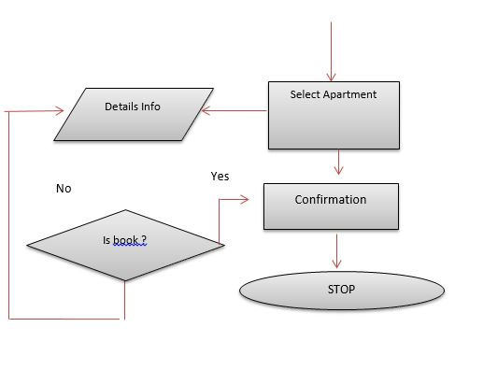

17

UML (Unified Modeling Language) Use Case Diagrams. Use case diagrams are usually referred to as behavior diagrams used to describe a set of actions (use cases) that some system or systems (subject) should or can perform in collaboration with one or more external users of the system (actors).

4.4 UML (Use Case) Diagram:

The UML (use case) diagram of E To-Let management system is given below:

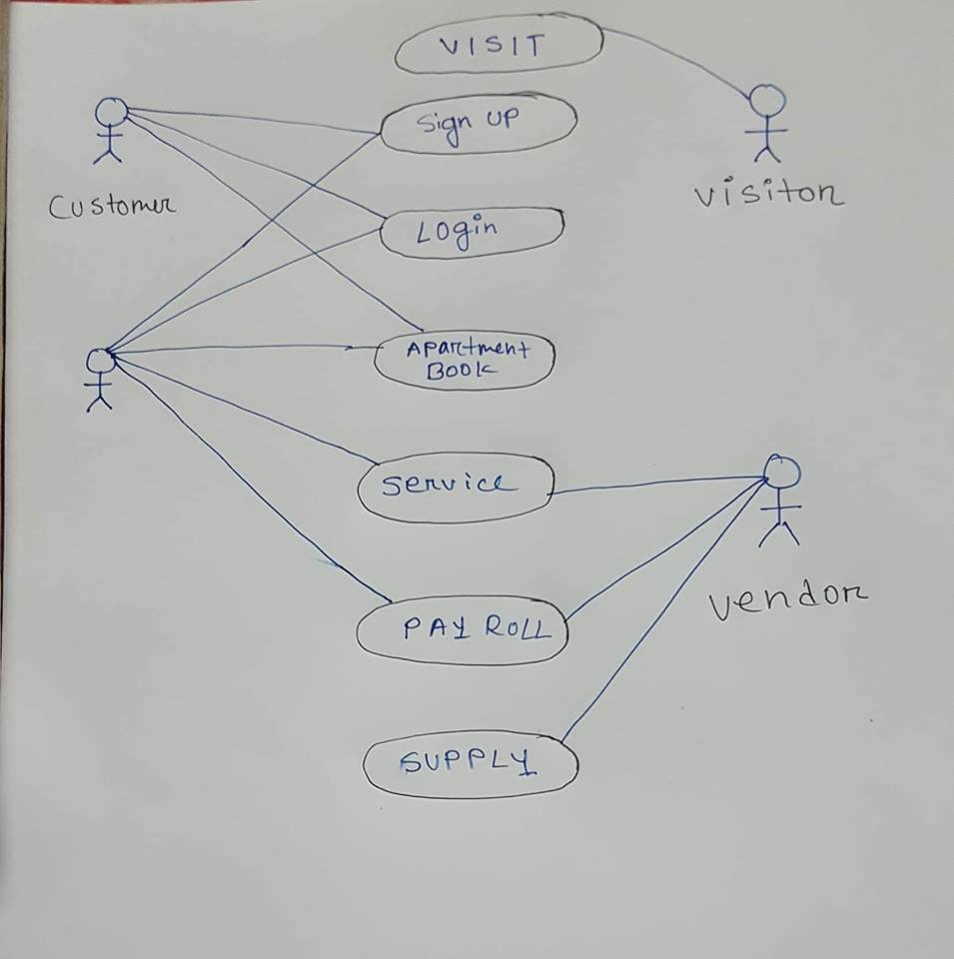  
   
 18